


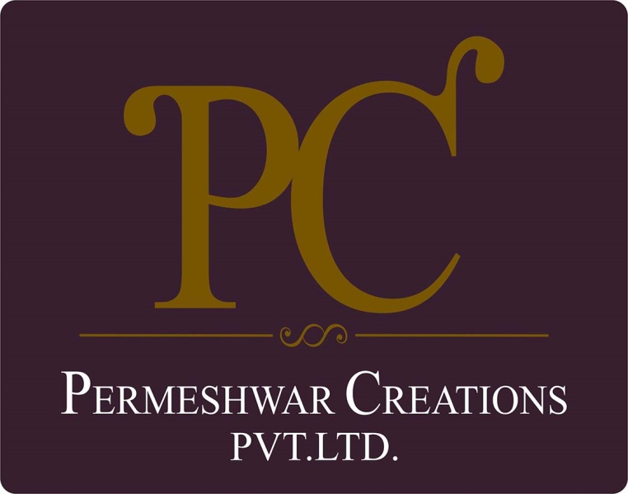

POLICY ON EQUAL OPPORTUNITY

With effective from: 01/04/2023
Revision: 1.1
Last review date: 01/01/2025
Next review date: 01/01/2026

Sr.No | Review Date | Prepared By | Approved By | Change Summary
1 | April 1, 2023 |  | Rishidev Gyandev Sadh | Initial Release Date
2 | Jan 1, 2024 |  | Rishidev Gyandev Sadh | Updated policy vision with Labor right Compliance.
3 | Jan 1, 2025 |  | Rishidev Gyandev Sadh | - Updated with defined goals for workplace safety, employee well-being, diversity, and fair labor practices.  - Updated role-based responsibilities.

Next Review Date: Jan 1, 2026

TABLE OF CONTENTS

Introduction 4
Scope 4
Policy Statement 4
Our Vision 4
SDGs Covered 7
Responsibility of this Policy 7
Review Mechanism 8
Employee Acknowledgement 9

Introduction
Permeshwar Creations is a renowned apparel manufacturing company in India, known for its commitment to quality, innovation, and sustainability. At Permeshwar Creations, we pride ourselves on being a leader in the apparel manufacturing industry. Since our inception, we have been dedicated to producing high-quality garments that meet the needs of our diverse clientele. Our research and development team continuously innovate, creating lightweight, fine-textured garments in a variety of beautiful colors and designs.

Scope
This policy comprehensively covers all aspects of Permeshwar Creation Pvt. Ltd.’s manufacturing and operation sites. It applies to all workers, employees, suppliers, and stakeholders, both internal and external, associated directly or indirectly with Permeshwar Creation Pvt. Ltd. Below are the locations of our two manufacturing units:

Permeshwar Creations Pvt. Ltd. | Unit 1 : Rishita Fashion | Plot no. 1102, Phase III, GIDC, Vapi, Valsad, Gujarat 396195
Permeshwar Creations Pvt. Ltd. | Unit 2 : PK Enterprises | C-19, Hoisery Complex, Phase II, Noida, U.P 201301. India

Policy Statement
Permeshwar Creations is committed to conducting business ethically and with integrity. We strive to prevent any form of corruption and ensure responsible management of information.

Our Vision
Below are our commitments and targets towards equal opportunity as compared to baseline year 2022.

- Workplace Safety and Health
- Ensure safety at work through comprehensive safety protocols.
- Promote physical and psychological health at work.
- Implement stress prevention measures.
- We aim to provide comprehensive health and safety training to our employees for better working practices.
- Achieve a 20% reduction in workplace accidents by 2025.
- We will achieve 100% employee participation in annual safety training programs by 2028.
- We will cultivate a culture of “zero harm” where all employees are empowered to report unsafe conditions without fear of reprisal.
- Work-Life Balance and Well-being
- Support work-life balance initiatives.
- Respect the right to disconnect after work hours.
- Regularly conduct employee satisfaction surveys.
- Provide competitive remuneration and social benefits.
- Increase overall employee satisfaction by 15% based on annual surveys.
- Aim to provide our employees with a health insurance program and conduct regular employee health check-ups.
- We will provide flexible working options (remote work, staggered hours) to at least 25% of employees by 2028.
- We aim to provide health insurance coverage to 100% of our employees by 2028.
- We will promote a workplace culture where mental health and well-being are openly discussed and supported.
- Employee Engagement and Communication
- Foster structured social dialogue through recognized employee representatives.
- Support collective bargaining processes.
- Conduct biannual meetings with employee representatives with an attendance rate of 90%.
- We aim to include all employees in the collective bargaining agreement.
- We aim to include 100% of employees in the collective bargaining agreement by 2028.
- We will achieve at least 85% employee participation in annual engagement surveys by 2028.
- We will maintain transparent and two-way communication channels (town halls, newsletters, digital platforms) for employees across all levels.
- Career Development and Advancement
- Ensure fair recruitment, evaluation, and promotion processes.
- Facilitate training and career development opportunities for all employees.
- Increase employee participation in professional development programs by 15% annually.
- We will ensure at least 80% of employees complete one skills enhancement training annually by 2028.
- We will build a culture of continuous learning by integrating mentorship and coaching programs into career development plans.
- Labor Rights Compliance
- Maintain zero tolerance for any incidents related to child labor, forced labor, or human trafficking.
- Provide training to employees on child labor, forced labor, and human trafficking.
- Conduct regular internal assessments on labor exploitation.
- Prohibit child labor, forced labor, and human trafficking in all company operations.
- 0% tolerance for any incidents related to child labor, forced labor, or human trafficking.
- By 2028, we will conduct annual third-party audits to verify compliance with labor rights standards across all facilities.
- We will foster an ethical workplace culture where respect for human rights is a shared responsibility at every level.
- Maintain zero reported cases related to child labor, forced labor, and human trafficking.
- Train 100% of employees on labor rights and related policies by 2028.
- By 2028, conduct annual third-party audits to verify compliance with labor rights standards across all facilities.
- Foster an ethical workplace culture where respect for human rights is a shared responsibility at every level.
- Diversity, Inclusion, Equal Opportunities, Discrimination, and Harassment
- Foster a zero-tolerance culture for discrimination and harassment.
- Prevent discrimination, harassment, and abuse in the workplace.
- Promote equal treatment and opportunities for employees from diverse backgrounds.
- Promote open communication channels for reporting incidents without fear of retaliation.
- Increase diversity in leadership roles by 25% by 2025.
- By 2028, we will achieve gender-balanced recruitment shortlists for at least 70% of open positions.
- We will strengthen an inclusive culture where employees feel valued, respected, and empowered to contribute fully.
- Maintain zero reported discrimination and harassment incidents.
- Achieve 100% employee completion of anti-discrimination and harassment training annually.
- Ethical Supply Chain Practices
- Ensure suppliers adhere to ethical labor practices and human rights standards.
- Conduct regular audits and assessments of supply chain partners.
- Achieve 100% compliance with ethical supply chain standards by 2025.
- We will train 100% of suppliers on ethical labor standards by 2025.
- We will prioritize long-term partnerships with suppliers who share our values on fairness, ethics, and human rights.
- Community Engagement and Social Impact
- Support local communities through sustainable initiatives.
- Mitigate negative social impacts of business operations.
- Increase community engagement projects by 20% annually.
- We will allocate at least 2% of annual profits to community development initiatives by 2028.
- We will build meaningful partnerships with NGOs, schools, and local organizations to create a positive and lasting social impact.

SDGs Covered
This policy aligns with the United Nations Sustainable Development Goals (SDGs), particularly:

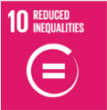

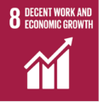



Responsibility of this Policy
The responsibility for implementing and upholding this Equal Opportunity Policy lies with every employee, director, officer, contractor, and agent of Parmeshwar Creations.
- Senior Management
- Demonstrate visible commitment to equal opportunity and non-discrimination.
- Ensure that business decisions, recruitment, promotions, and other employment practices are free from bias.
- Allocate necessary resources to support equal opportunity initiatives and programs.
- Chief Human Resources Officer (CHRO)
- Review and update this policy annually to ensure alignment with legal requirements and best practices.
- Monitor implementation effectiveness and recommend improvements.
- Oversee overall compliance with equal opportunity and non-discrimination standards across the organization.
- Human Resource Manager (HR)
- Lead the execution of this policy across all levels of the organization.
- Develop, implement, and monitor equal opportunity practices, including recruitment, training, and promotions.
- Provide regular training and awareness programs on diversity, inclusion, and fair treatment.
- Establish reporting and grievance mechanisms for addressing concerns of discrimination or bias.
- Department Heads & Supervisors
- Ensure fair and consistent treatment of employees within their teams.
- Integrate equal opportunity principles into daily operations, decision-making, and performance management.
- Encourage open communication and report any breaches of this policy to HR.
- Employees, Contractors, and Agents
- Comply with the principles of equal opportunity in their daily conduct and workplace interactions.
- Treat colleagues, clients, and stakeholders with fairness, dignity, and respect.
- Report any observed discrimination, harassment, or unfair treatment through the appropriate reporting channels.

Review Mechanism
This policy will undergo annual reviews overseen by the Chief Human Resources Officer, with the next review scheduled for 1st January 2026. Updates or amendments will be communicated to all stakeholders accordingly. Regular audits and reporting will ensure ongoing compliance with the policy's objectives and principles.

Approved by: Rishidev Gyandev Sadh
Designation: General Manager of Operations
Date:

Employee Acknowledgement
I, _________________, acknowledge that I have read and understood this Policy. I commit to upholding the principles outlined therein, including preventing corruption, ensuring responsible information management, promoting environmental sustainability, upholding supplier ethics, fostering a safe and inclusive workplace, and contributing positively to the Sustainable Development Goals (SDGs). I understand that compliance with this policy is a fundamental expectation and a condition of my employment with Permeshwar Creations.

Employee Name:

Employee Signature:

Date:

